AWS Cloud Offerings Explained: Compute, Storage, Networking &More

Types of Cloud Offerings
A cloud offering means what services a cloud provider gives you over the internet instead of using your own physical servers.
Cloud offerings are the different services provided by cloud companies (like AWS, Azure, Google Cloud) that let you use IT resources over the internet instead of owning physical hardware.
Cloud offerings describe what level of service the cloud provider gives you and what you manage yourself.
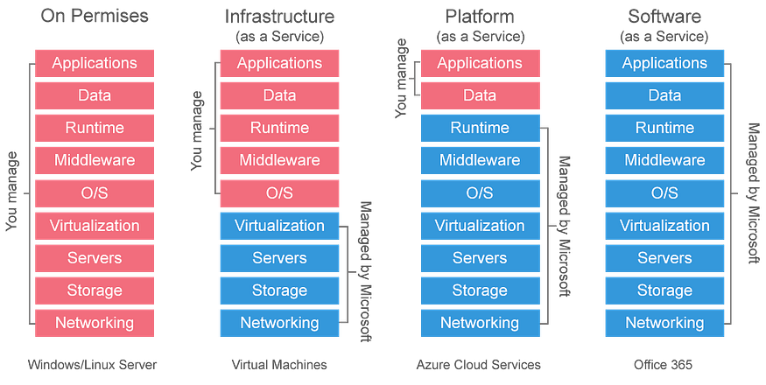

Main Cloud Offerings

1.Infrastructure as a Service (IaaS)
Renting IT infrastructure
Explanation:
You get virtual servers, storage, and networking from the cloud.
You are responsible for installing the OS, software, and managing everything on top of it.
Example:
AWS EC2, Azure VM
Real-life analogy:
Renting an empty house - you bring furniture, appliances, and maintain it.
Used by:
System admins, DevOps engineers
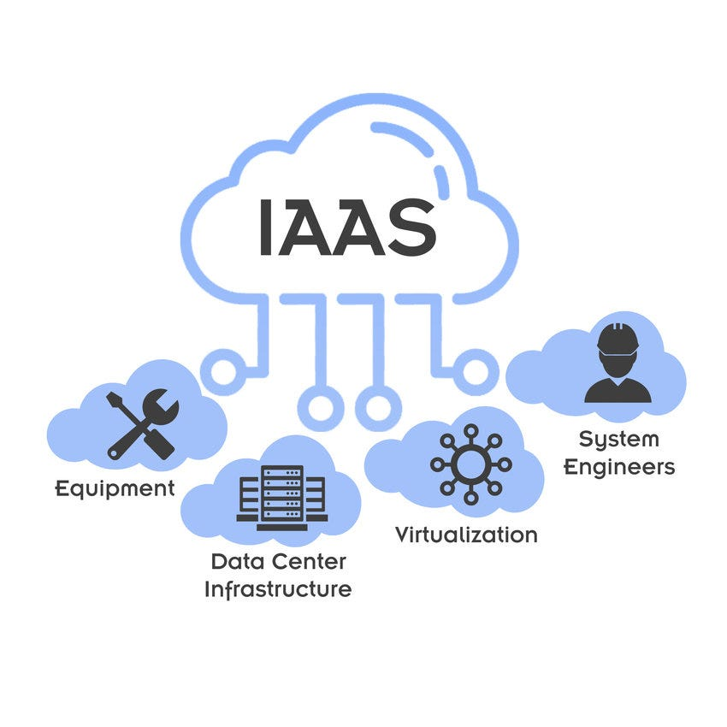

2.Platform as a Service (PaaS)
Ready platform to build applications
Explanation:
The cloud provider manages servers, OS, and runtime.
You only focus on writing and deploying your application code.
Example:
AWS Elastic Beanstalk
Google App Engine
Real-life analogy:
Renting a furnished house - you just live and use it.
Used by:
Application developers

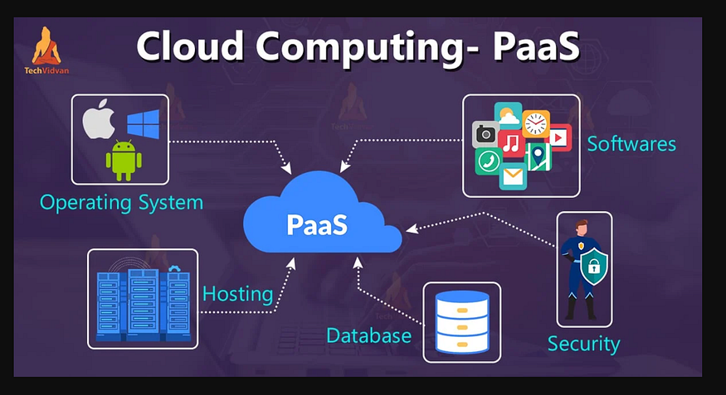

3. Software as a Service (SaaS)
Complete software over the internet
Explanation:
You directly use the software without worrying about servers or updates.
Example:
Gmail, Zoom, Microsoft 365
Real-life analogy:
Staying in a hotel - everything is managed for you.
Used by:
End users & businesses
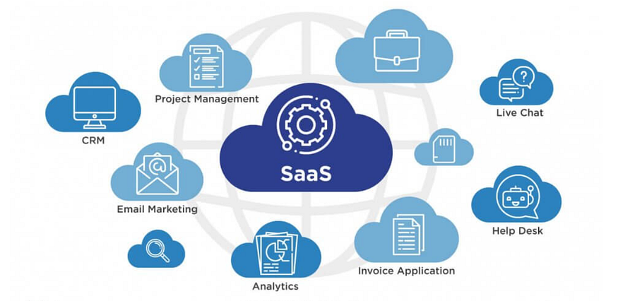

Quick Comparison
Type | What You Manage | What Cloud Manages
IaaS | OS, apps, data | Hardware, VM
PaaS | Application code | OS, runtime
SaaS | Nothing | Everything

In AWS, cloud offerings mean the services AWS provides over the cloud so you don’t need to buy or manage physical servers, storage, or networking.
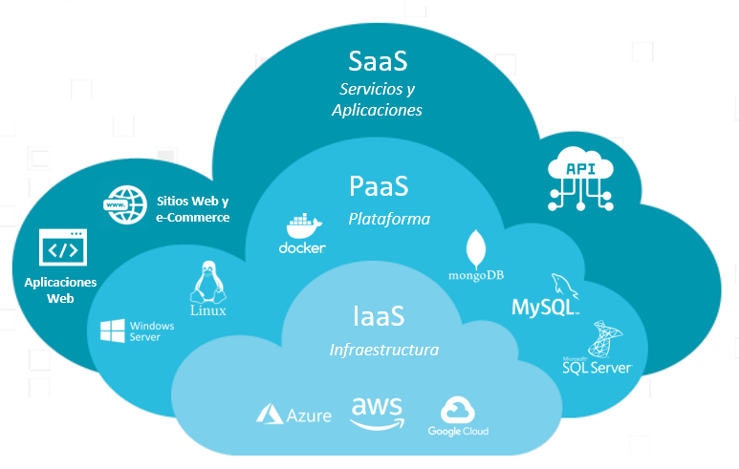

Main Cloud Offerings in AWS

1. Compute (Servers in the Cloud)
Used to run applications and workloads.
- EC2 – Virtual servers
- Lambda – Run code without managing servers (serverless)
- Elastic Beanstalk – Deploy apps easily
Example: Hosting a website or running an application.

2. Storage (Save Data in the Cloud)
Used to store files, backups, and data.
- S3 – Object storage (images, videos, backups)
- EBS – Disk storage for EC2
- EFS – Shared file storage
Example: Storing photos, logs, or database backups.

3. Database (Managed Databases)
AWS manages database setup, patching, and scaling.
- RDS – MySQL, PostgreSQL, Oracle, etc.
- DynamoDB – NoSQL database
- Aurora – High-performance database
Example: Storing user data for an app.

4. Networking & Content Delivery
Used to connect resources securely and deliver content fast.
- VPC – Private network in AWS
- Route 53 – DNS service
- CloudFront – Content Delivery Network (CDN)
Example: Secure access to your application worldwide.

5. Security & Identity
Protect your AWS resources.
- IAM – Users and permissions
- KMS – Encryption keys
- Shield & WAF – DDoS protection
Example: Controlling who can access AWS resources.

6. Monitoring & Management
Track performance and costs.
- CloudWatch – Logs and monitoring
- CloudTrail – Track user activity
- AWS Config – Resource compliance
Example: Monitoring CPU usage and logs.

7. DevOps & Developer Tools
Help with CI/CD and automation.
- CodeCommit
- CodeBuild
- CodeDeploy
- CodePipeline
Example: Automatically deploy code after updates.

8. AI, ML & Analytics
Advanced data processing and intelligence.
- SageMaker – Machine learning
- Athena – Query S3 data
- Redshift – Data warehouse
Example: Data analysis and predictions.

In One Line
AWS cloud offerings provide compute, storage, databases, networking, security, and tools—on demand, scalable, and pay-as-you-go.

